ReactJS Hands-on 17
Consume REST API using Fetch

Project Structure

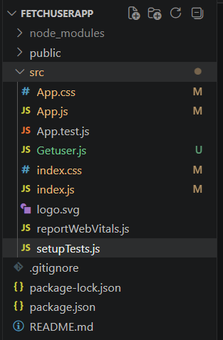

App.js
import './App.css';
import Getuser from './Getuser';
function App(){
return <Getuser/>;
}
export default App;

Getuser.js
import React,{Component} from 'react';
class Getuser extends Component{
state={title:'',first:'',picture:'',loading:true};
async componentDidMount(){
const response=await fetch('https://api.randomuser.me/');
const data=await response.json();
const user=data.results[0];
this.setState({
title:user.name.title,
first:user.name.first,
picture:user.picture.large,
loading:false
});
}
render(){
if(this.state.loading) return <h2>Loading...</h2>;
return(
<div style={{margin:'40px'}}>
<h1>{this.state.title} {this.state.first}</h1>
<img src={this.state.picture} alt='User'/>
</div>
);
}
}
export default Getuser;

index.js
import React from 'react';
import ReactDOM from 'react-dom/client';
import './index.css';
import App from './App';
const root=ReactDOM.createRoot(document.getElementById('root'));
root.render(<App/>);

App.css
body{
font-family:Arial,sans-serif;
}

Output
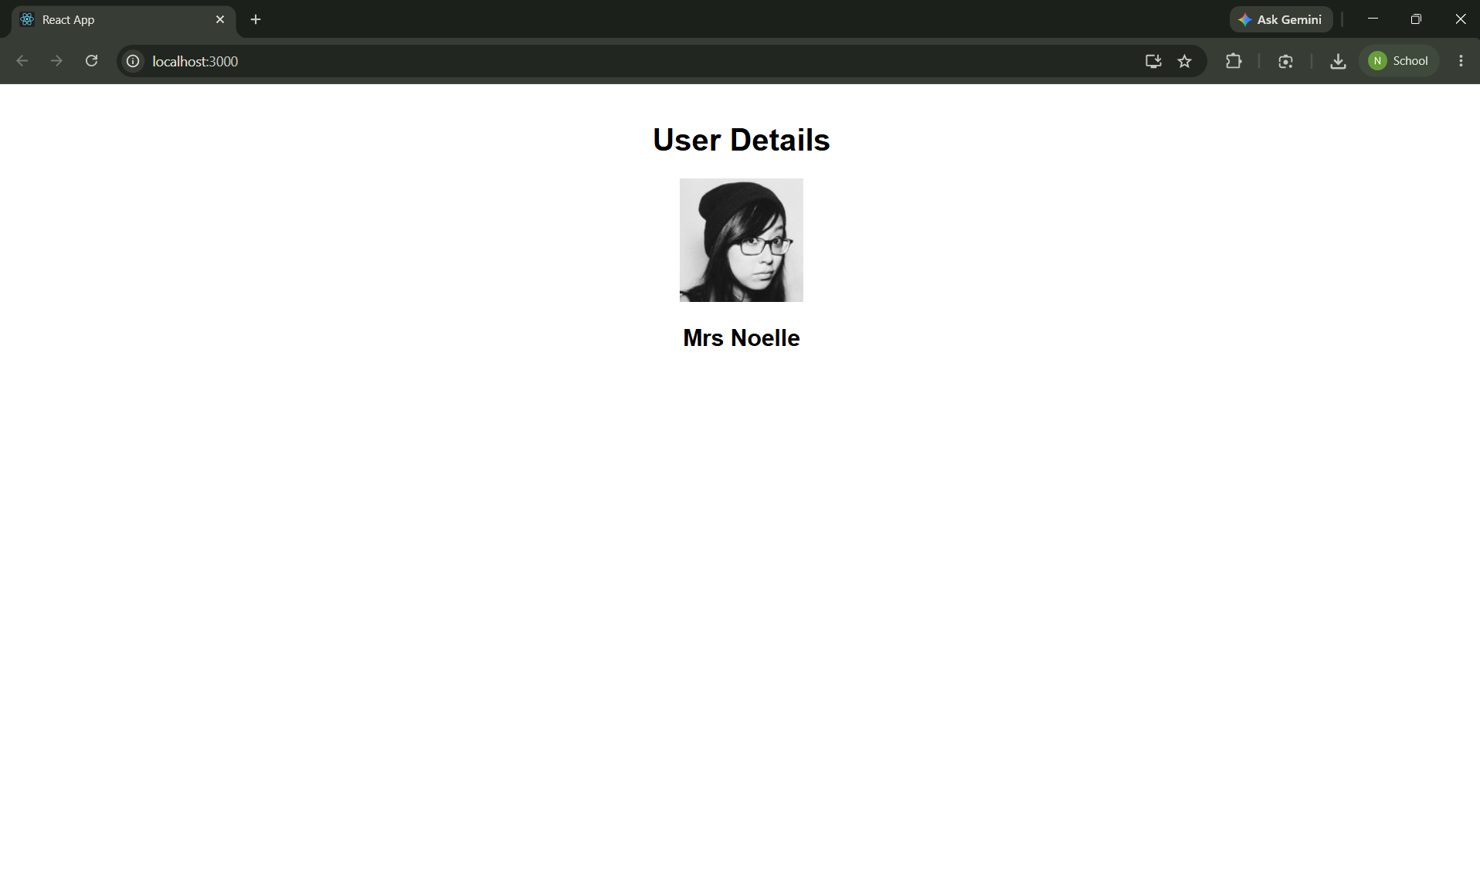

Conclusion
Successfully created a React application that consumes a REST API using fetch() inside componentDidMount() and displays the retrieved user information.

